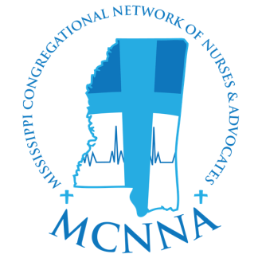
MISSISSIPPI CONGREGATIONAL NETWORK
OF NURSES AND ADVOCATES

Membership Application
Please Print Clearly in Black Ink

OCCUPATIONAL BACKGROUND
(For the past 2 years) Please list all relevant information concerning your current occupation and employer. Please indicate your years of employment. _________________________________________

_________________________________________

_________________________________________

VOLUNTEERISM
List any activities that you served in a volunteer capacity. Please include the name and location of the organization.
_________________________________________

_________________________________________

_________________________________________

ORGANIZATIONAL KNOWLEDGE
Do you have prior knowledge of MCNNA? □ Yes □ No
In your own words, describe what you will be able to bring to MCNNA if voted on favorably
_________________________________________

_________________________________________

_________________________________________

References: Name, relation, and contact information including phone numbers. Please provide at least three (3) references.

_________________________________________

_________________________________________

_________________________________________
GENERAL INFORMATION

_________________________________________________
First Name Middle Name Last Name

_________________________________________________
Home Phone Work Phone Cell Phone

_________________________________________________
Home Address City, State, Zip

_________________________________________________
Email Address

_________________________________________
Church Name/Affiliation

_________________________________________________
Church Address City, State, Zip

Are you a one of the following –

____ Congregational Health Nurse or Advocate (CHN/A)

____ Faith Community Nurse (FCN)

If yes, CHN/A or FCN course -

Completion Date _______ Location___________________

Does your church have a Health and Wellness Ministry?

□ Yes □ No What is your role in this ministry?

_________________________________________

_________________________________________

_________________________________________

_________________________________________

ACADEMIC BACKGROUND
List all academic history and include any honors received. Please include when and where?

_________________________________________

_________________________________________

_________________________________________

_________________________________________

_________________________________________

By returning this application form along with my $50 enrollment fee, I agree to attend and complete Congregations Health Nurse and Advocate training within 1 (one) calendar year from date of this application.

Date ______________ Signature _____________________________________________

Return this form along with $50 enrollment fee to
Mississippi Congregational Network of Nurses and Advocates, LLC (MCNNA)
P.O. Box 12085, Jackson, MS 39236

